**EXP NO 3: CREATE A SIMPLE CLOUD SOFTWARE APPLICATION FOR PROPERTY BUYING &**

**RENTAL PROCESS (IN CHENNAI CITY) USING ANY CLOUD SERVICE PROVIDER TO**

**DEMONSTRATE SAAS.**

**DATE:**

**AIM:**

To Create a simple cloud software application for Property Buying & Rental process

(In Chennai city) using any Cloud Service Provider to demonstrate SaaS.

**PROCEDURE:**

step1: Go to zoho.com.

step 2: Log into the zoho.com.

step 3: Select one application step.

step4: Enter application name as property buying & rental.

step 5: Created new application as property buying & rental.

step 6: Select one form

step 7: The software has been created.

**IMPLEMENTATION:**

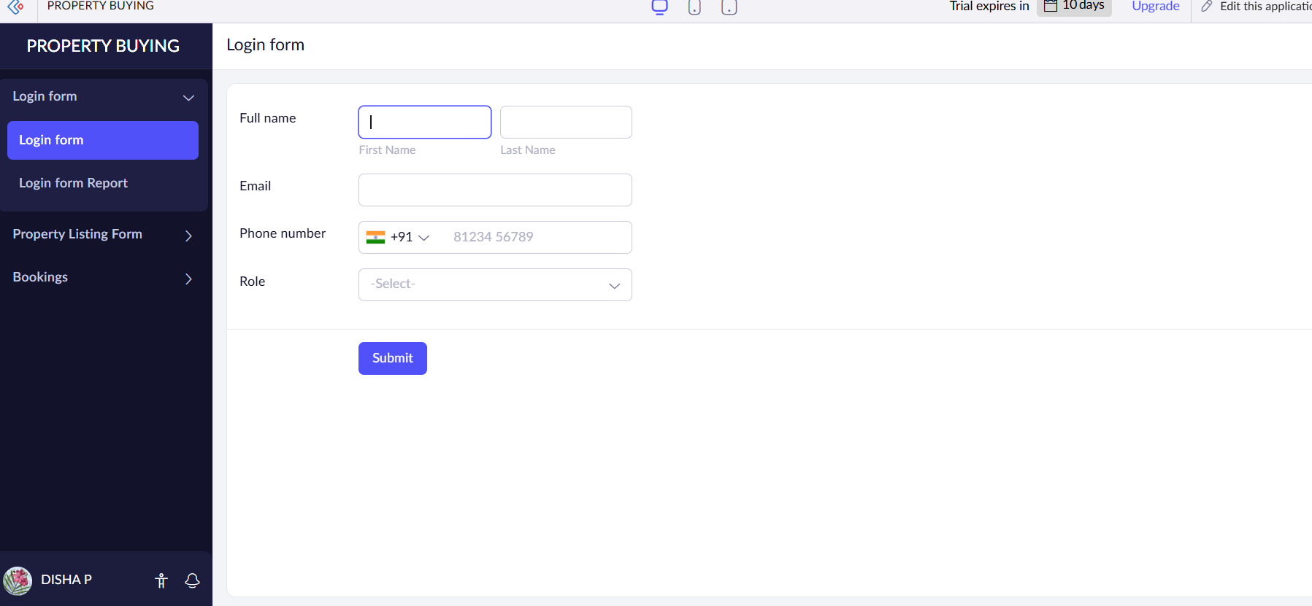

Login form details have been created

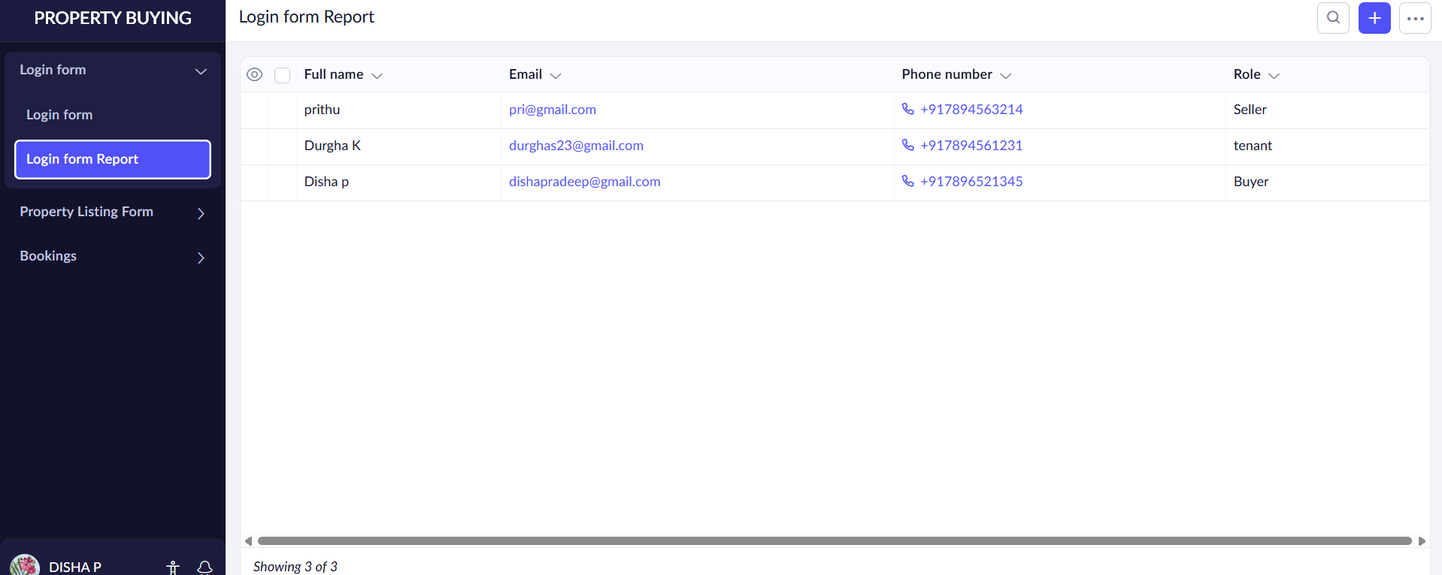

The details of Login form has been filled.

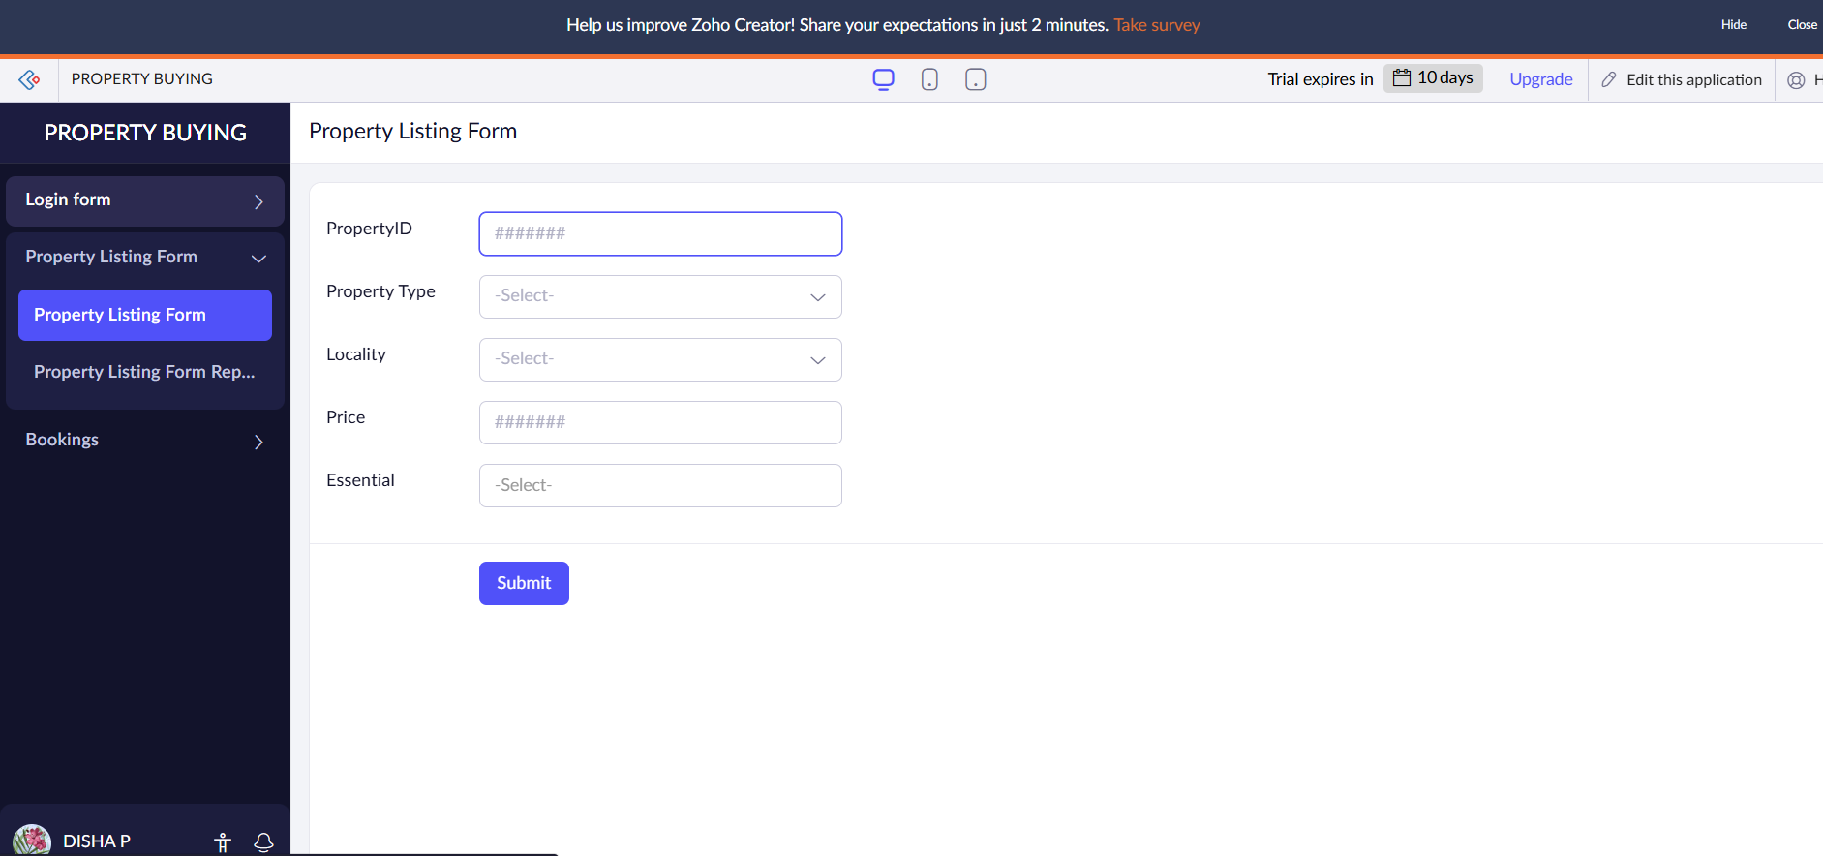

The property listing form has been created.

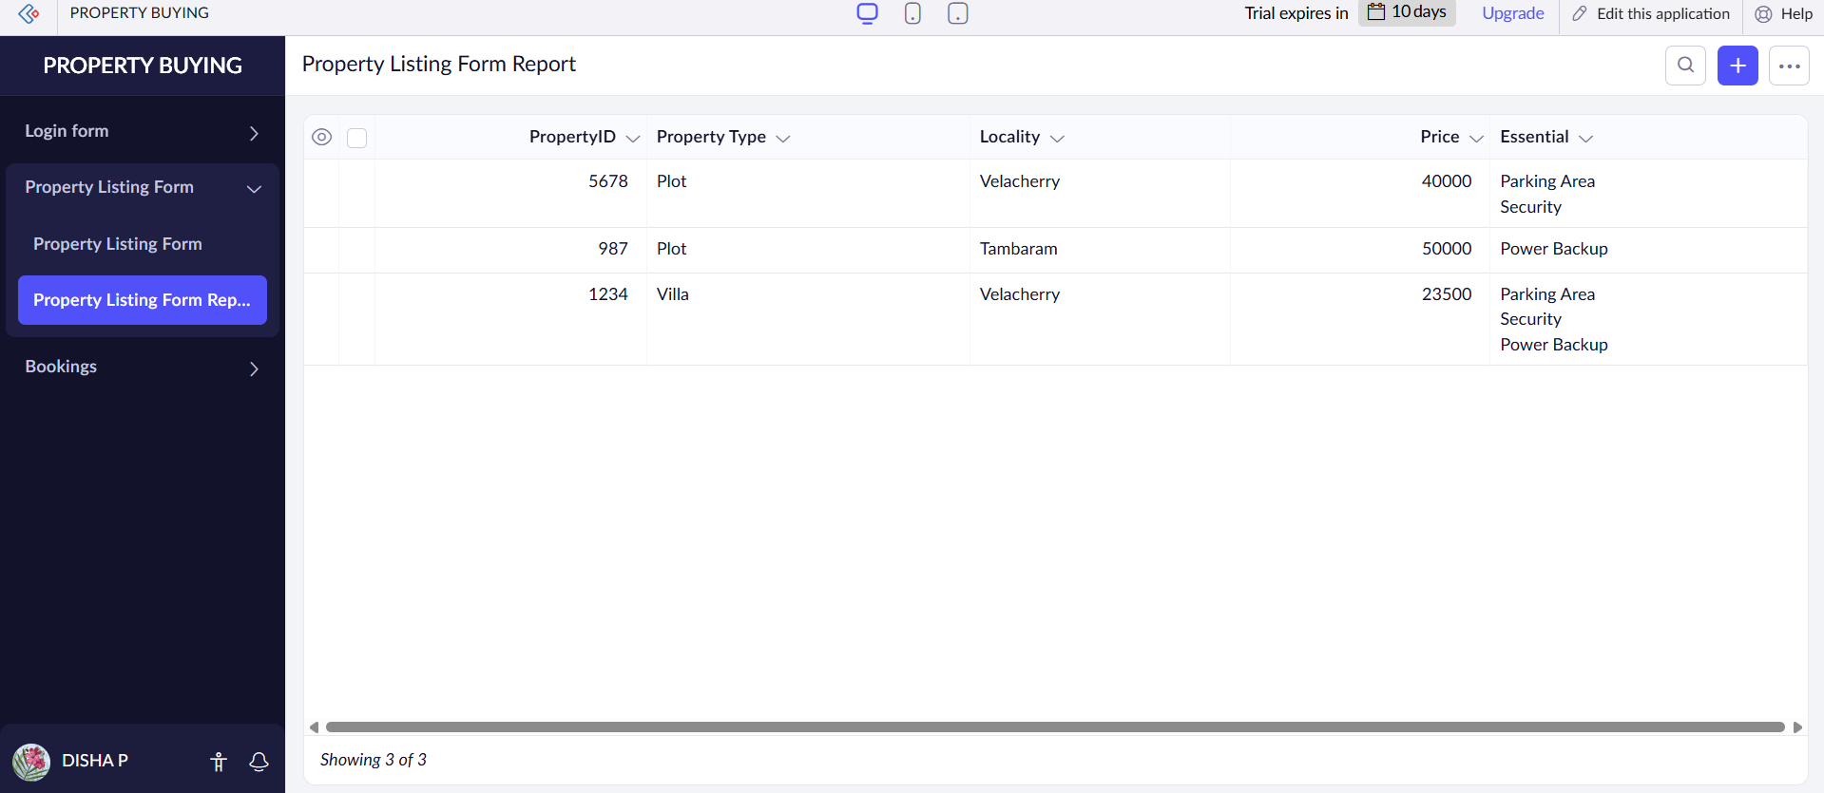

The details have been filled.

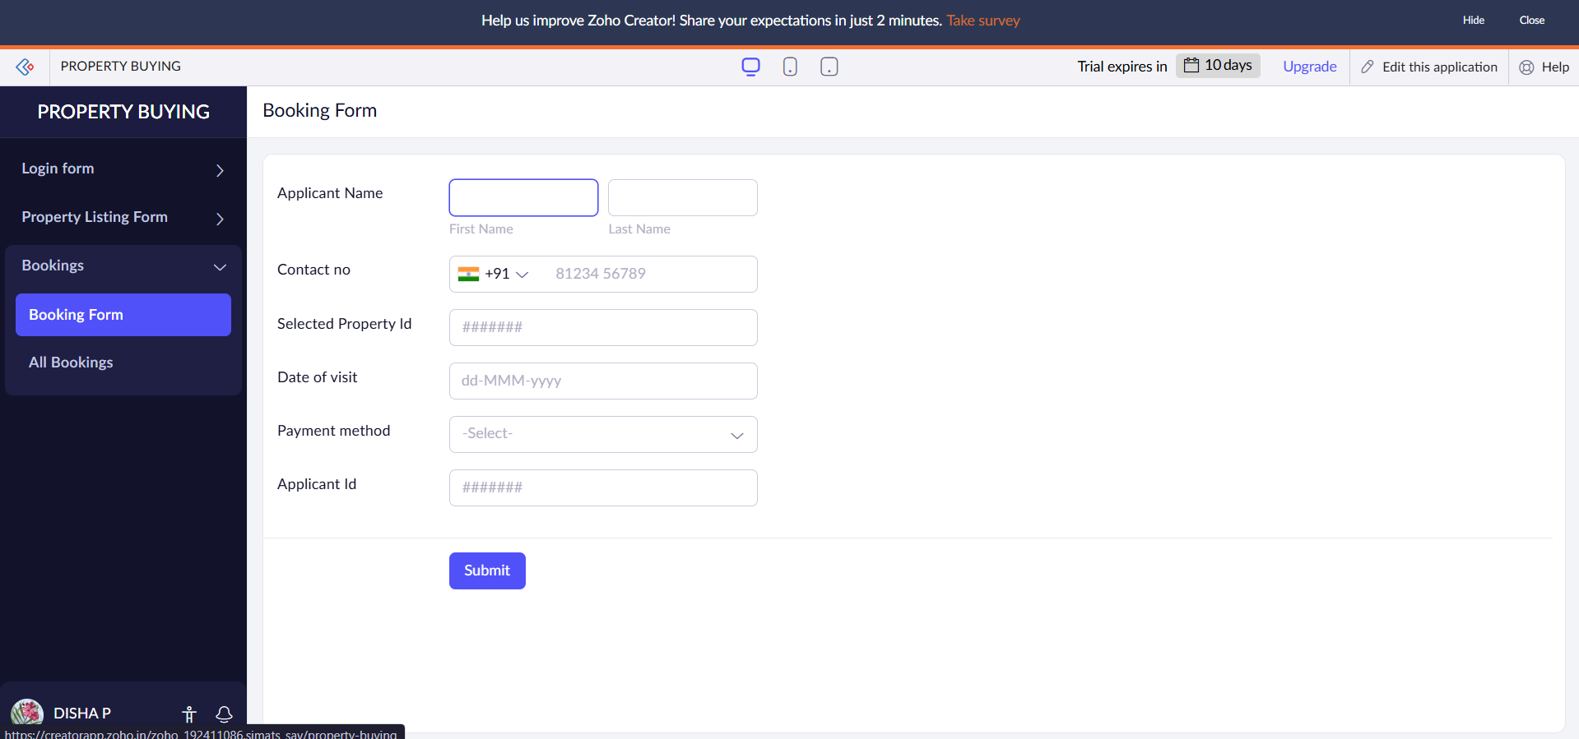

This form has been created to fill details.

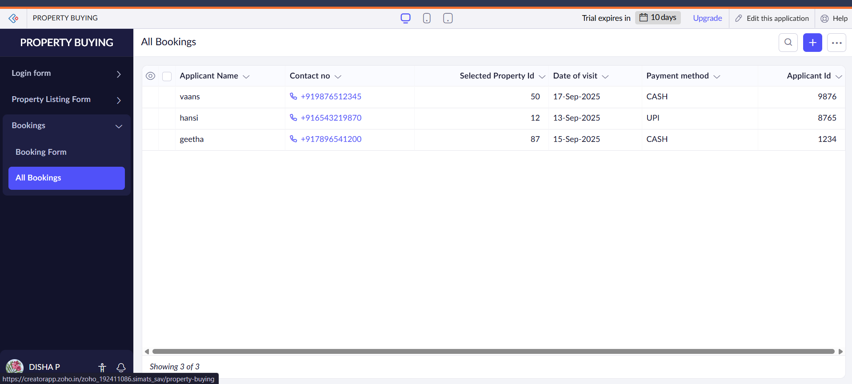

The details have been filled

Result:

Thus flight booking reservation system form has been done.